**Testing Table**

**Abdullah Alabdullah**

**07/11/2020**

**Testing Table**

|  |  |  |  |  |
| --- | --- | --- | --- | --- |
| Test No. | Tested Item | Expected Result | Actual Result | Passed/Failed |
| 1 | The warning message for students with an exam mark of less than 25. | This student is at risk | This student is at risk | Passed (Figure 1) |
| 2 | The warning message for students with an exam mark of 25 or more. | No Risk | No Risk | Passed (Figure 2) |
| 3 | The A to Z sorting button. | Student names are sorted from A to Z | Student names are sorted from A to Z | Passed (Figure 3) |
| 4 | The Z to A sorting button. | Student names are sorted from Z to A | Student names are sorted from Z to A | Passed (Figure 4) |
| 5 | Sheet protection. | Prevent the user from editing the sheet. | The spreadsheet is protected, and the user cannot edit the sheet. | Passed (Figure 5) |
| 6 | The number of students with distinction marks. | The number increases as more students achieve distinction. | The number has increased. | Passed (Figure 6) |
| 7 | Unlocked cell. | Users can enter student names in the unlocked cell. | The unlocked cell has accepted the value. | Passed (Figure 7) |

**Figures**

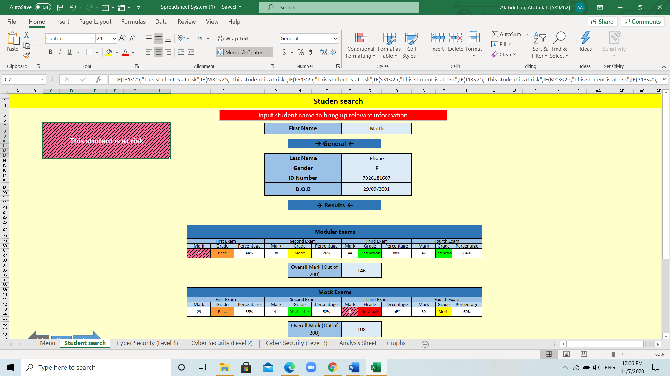

(Figure 1)

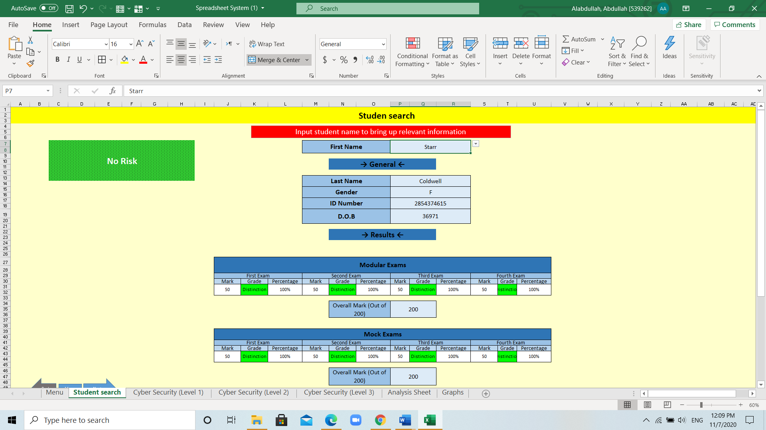

(Figure 2)

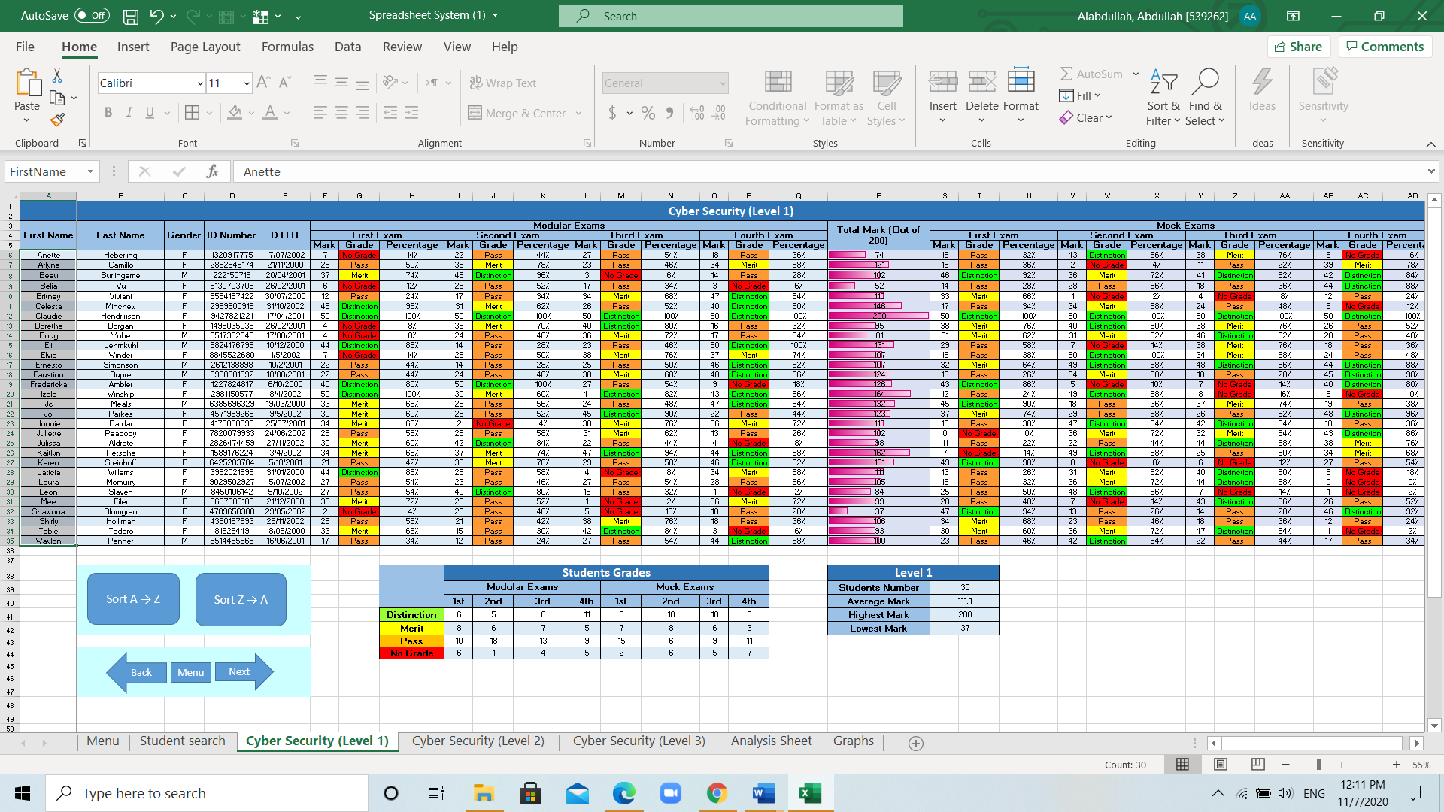

(Figure 3)

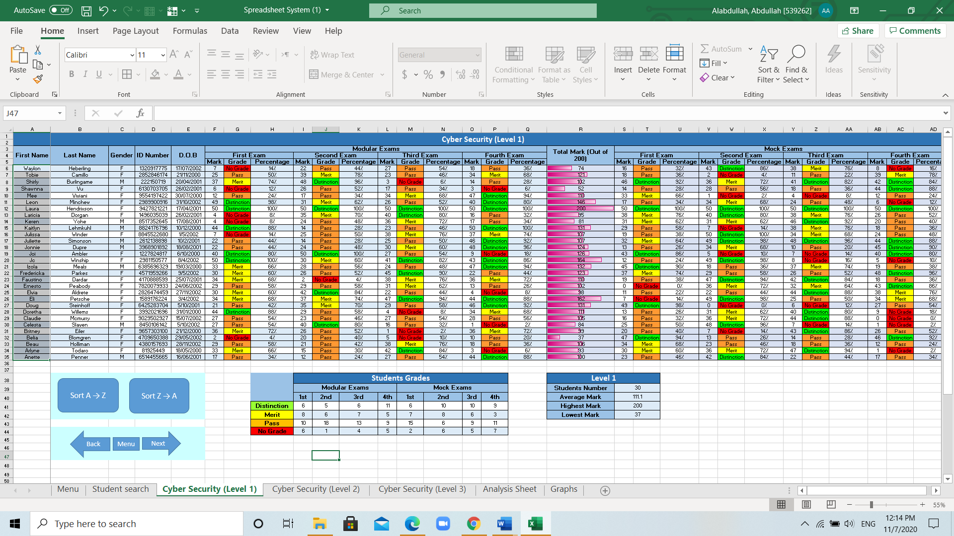

(Figure 4)

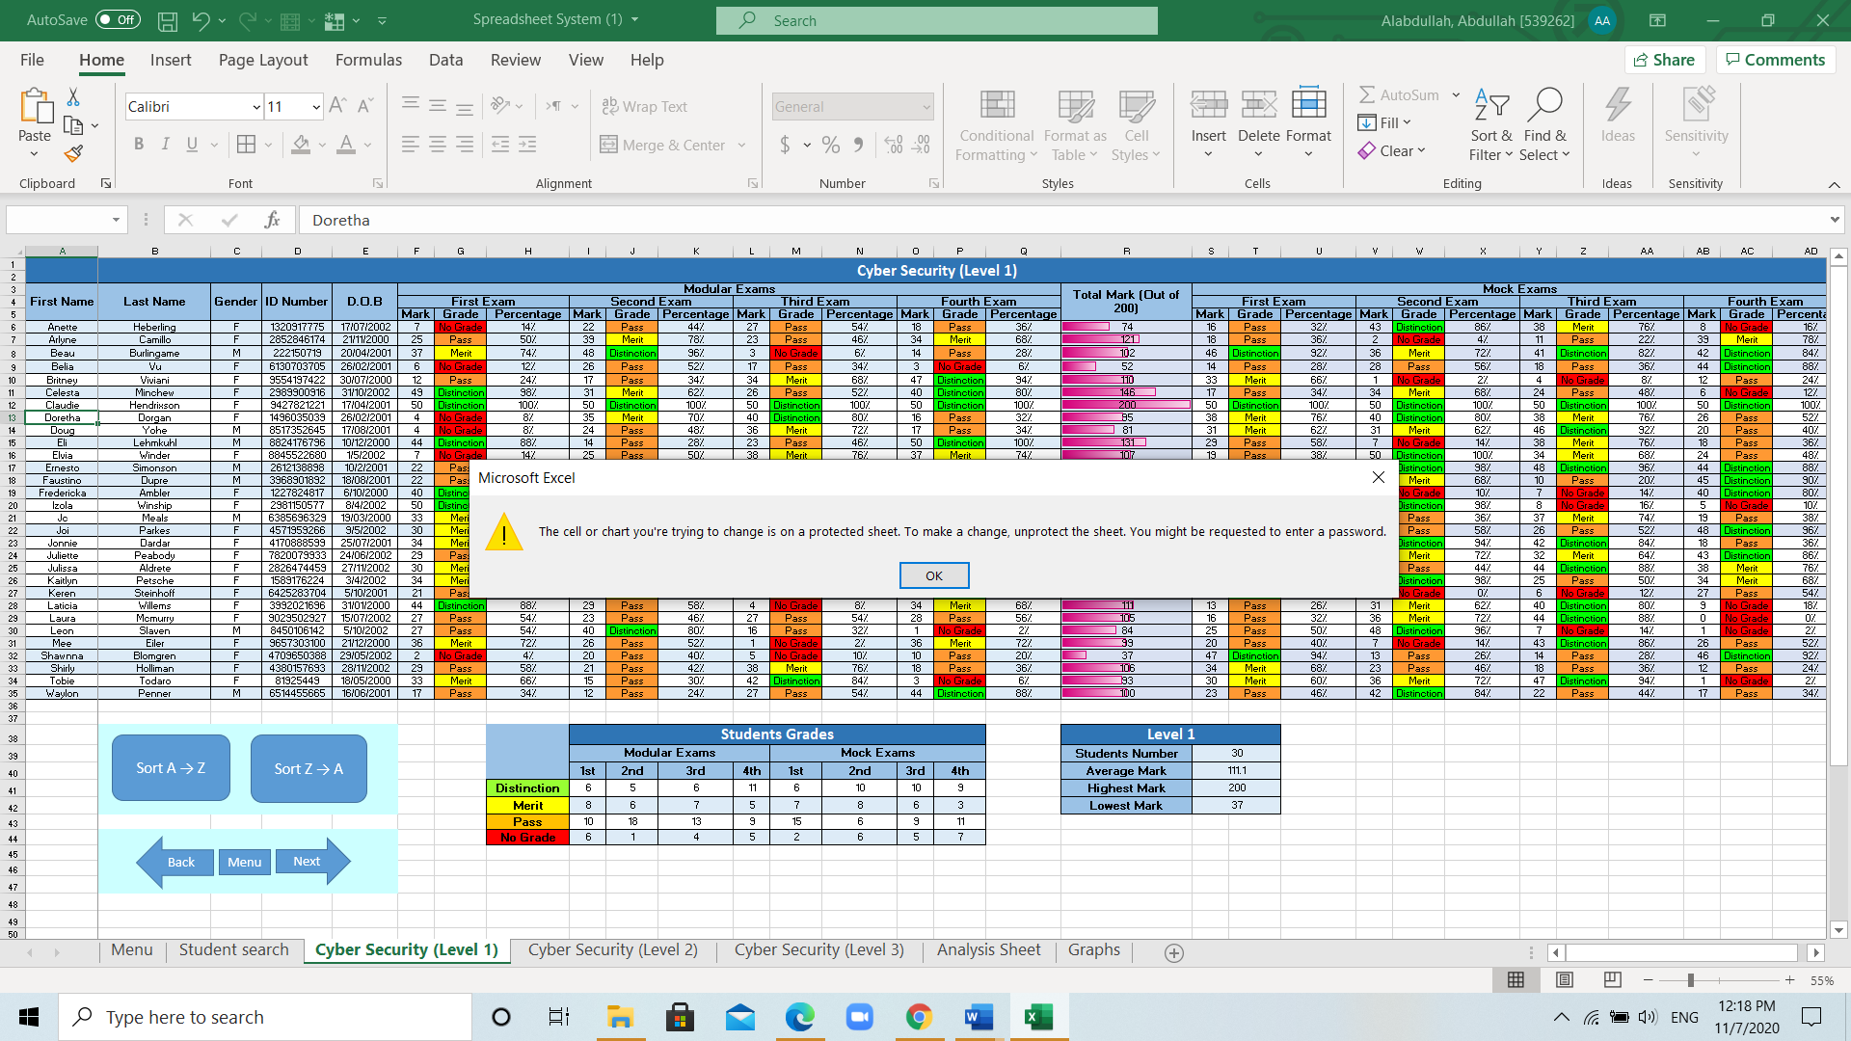

(Figure 5)

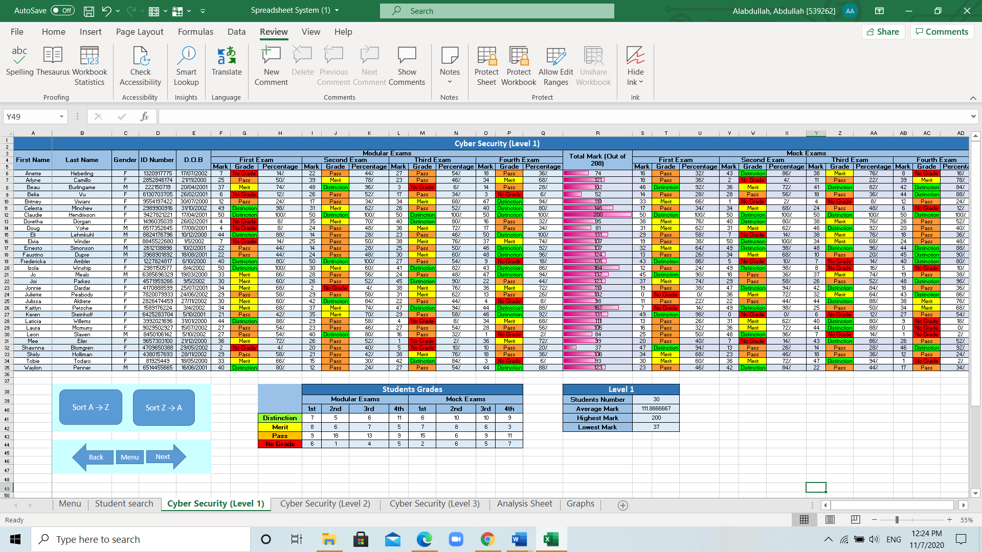 **Before** **After**

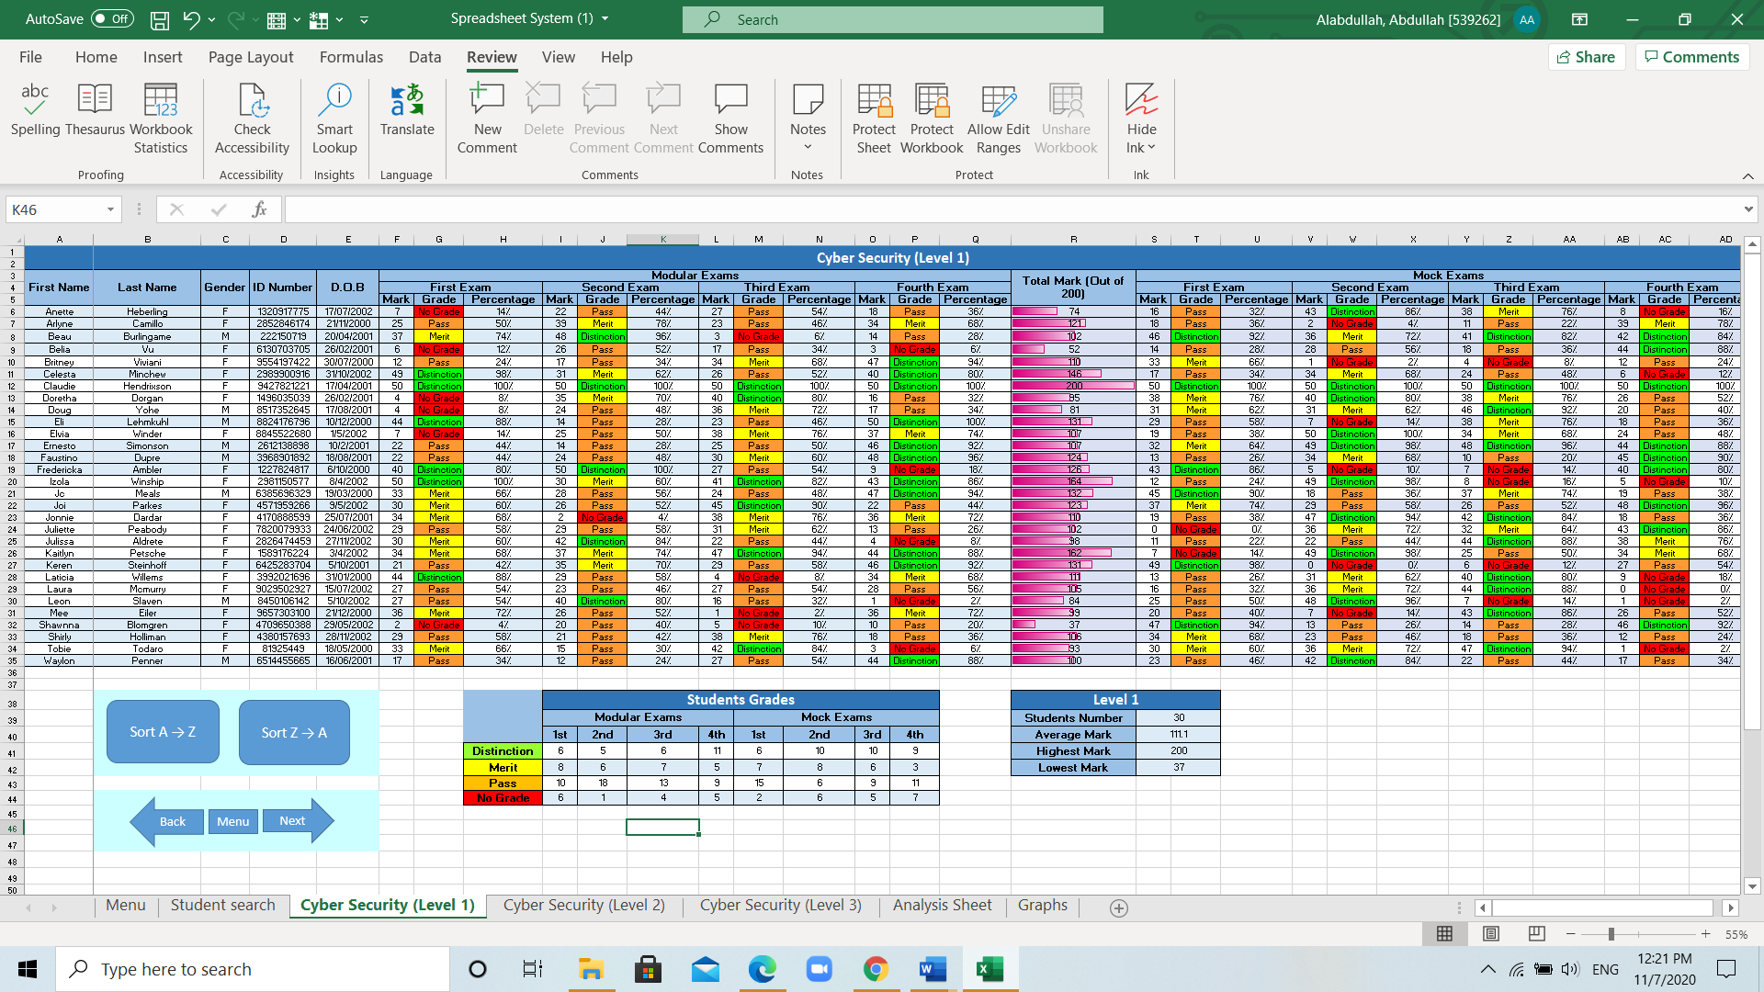

(Figure 6-1) (Figure 6-2)

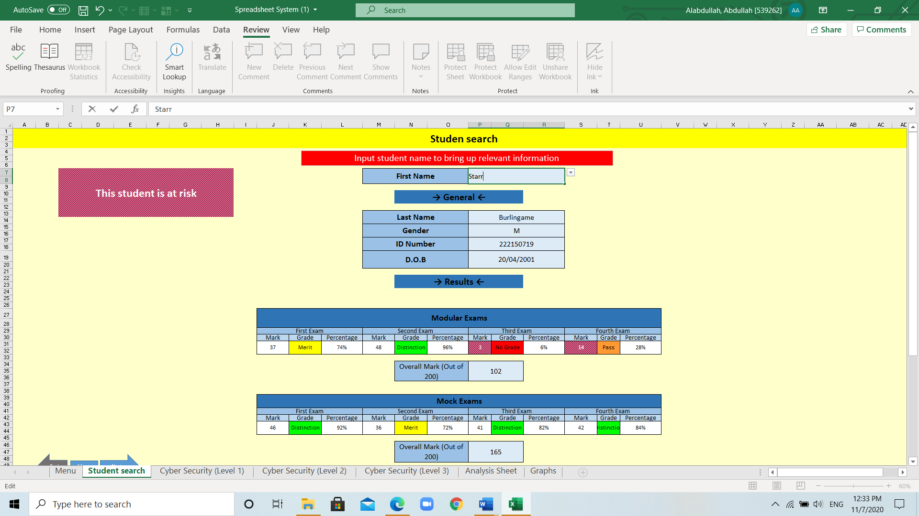

(Figure 7)